Name: Ahmed Hisham saber Abdallah elsisy

B.N: 155

Date:6/6/2021

Topic: Artificial Intelligence

Faculty of Engineering shoubra

# Application Breif:

I chosed this application because A[rtificial intelligence (AI)](https://www.bbntimes.com/companies/understanding-artificial-intelligence-machine-learning-and-deep-learning) is one such technology that is gaining momentum and hype. With technology becoming a part of our everyday lives, AI has become a topic of debates and discussions where technocrats consider it as a blessing and for some, it is a disaster. Having said that, we are still unsure about the future of artificial intelligence. Is artificial intelligence a threat or a blessing?

# Screen Shots:

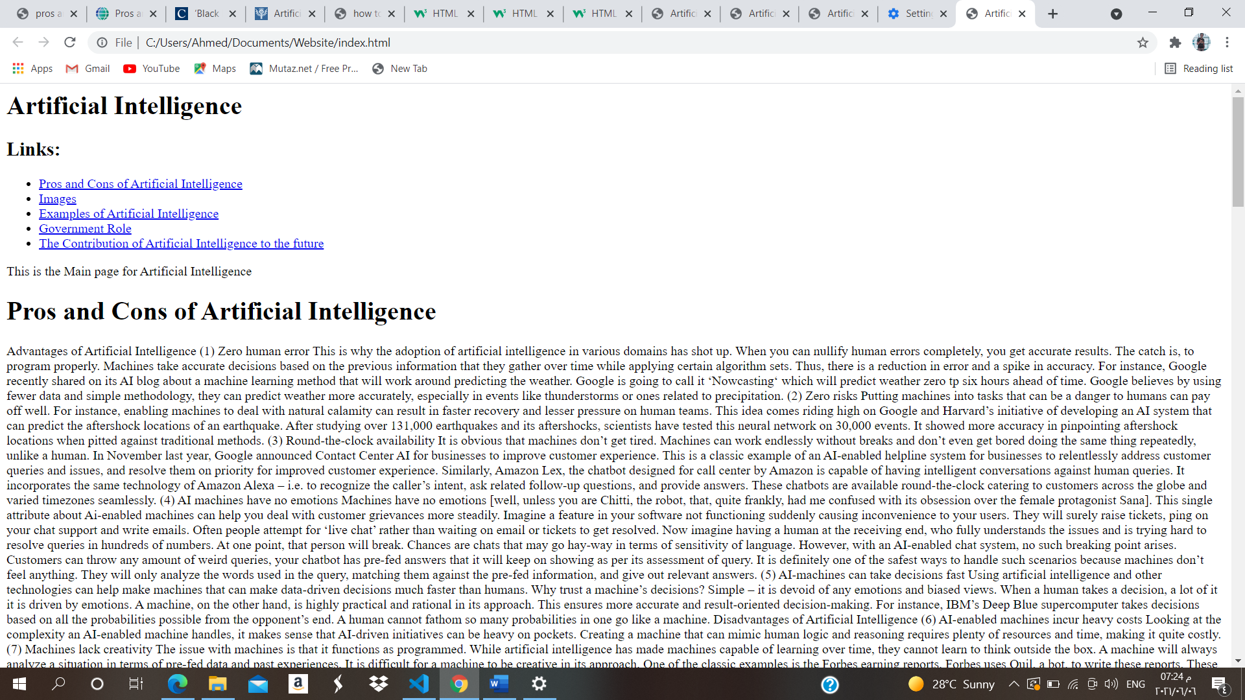

# Source Code:

